Increasing Fuel Efficiency in Trucks
By Joel Levitt
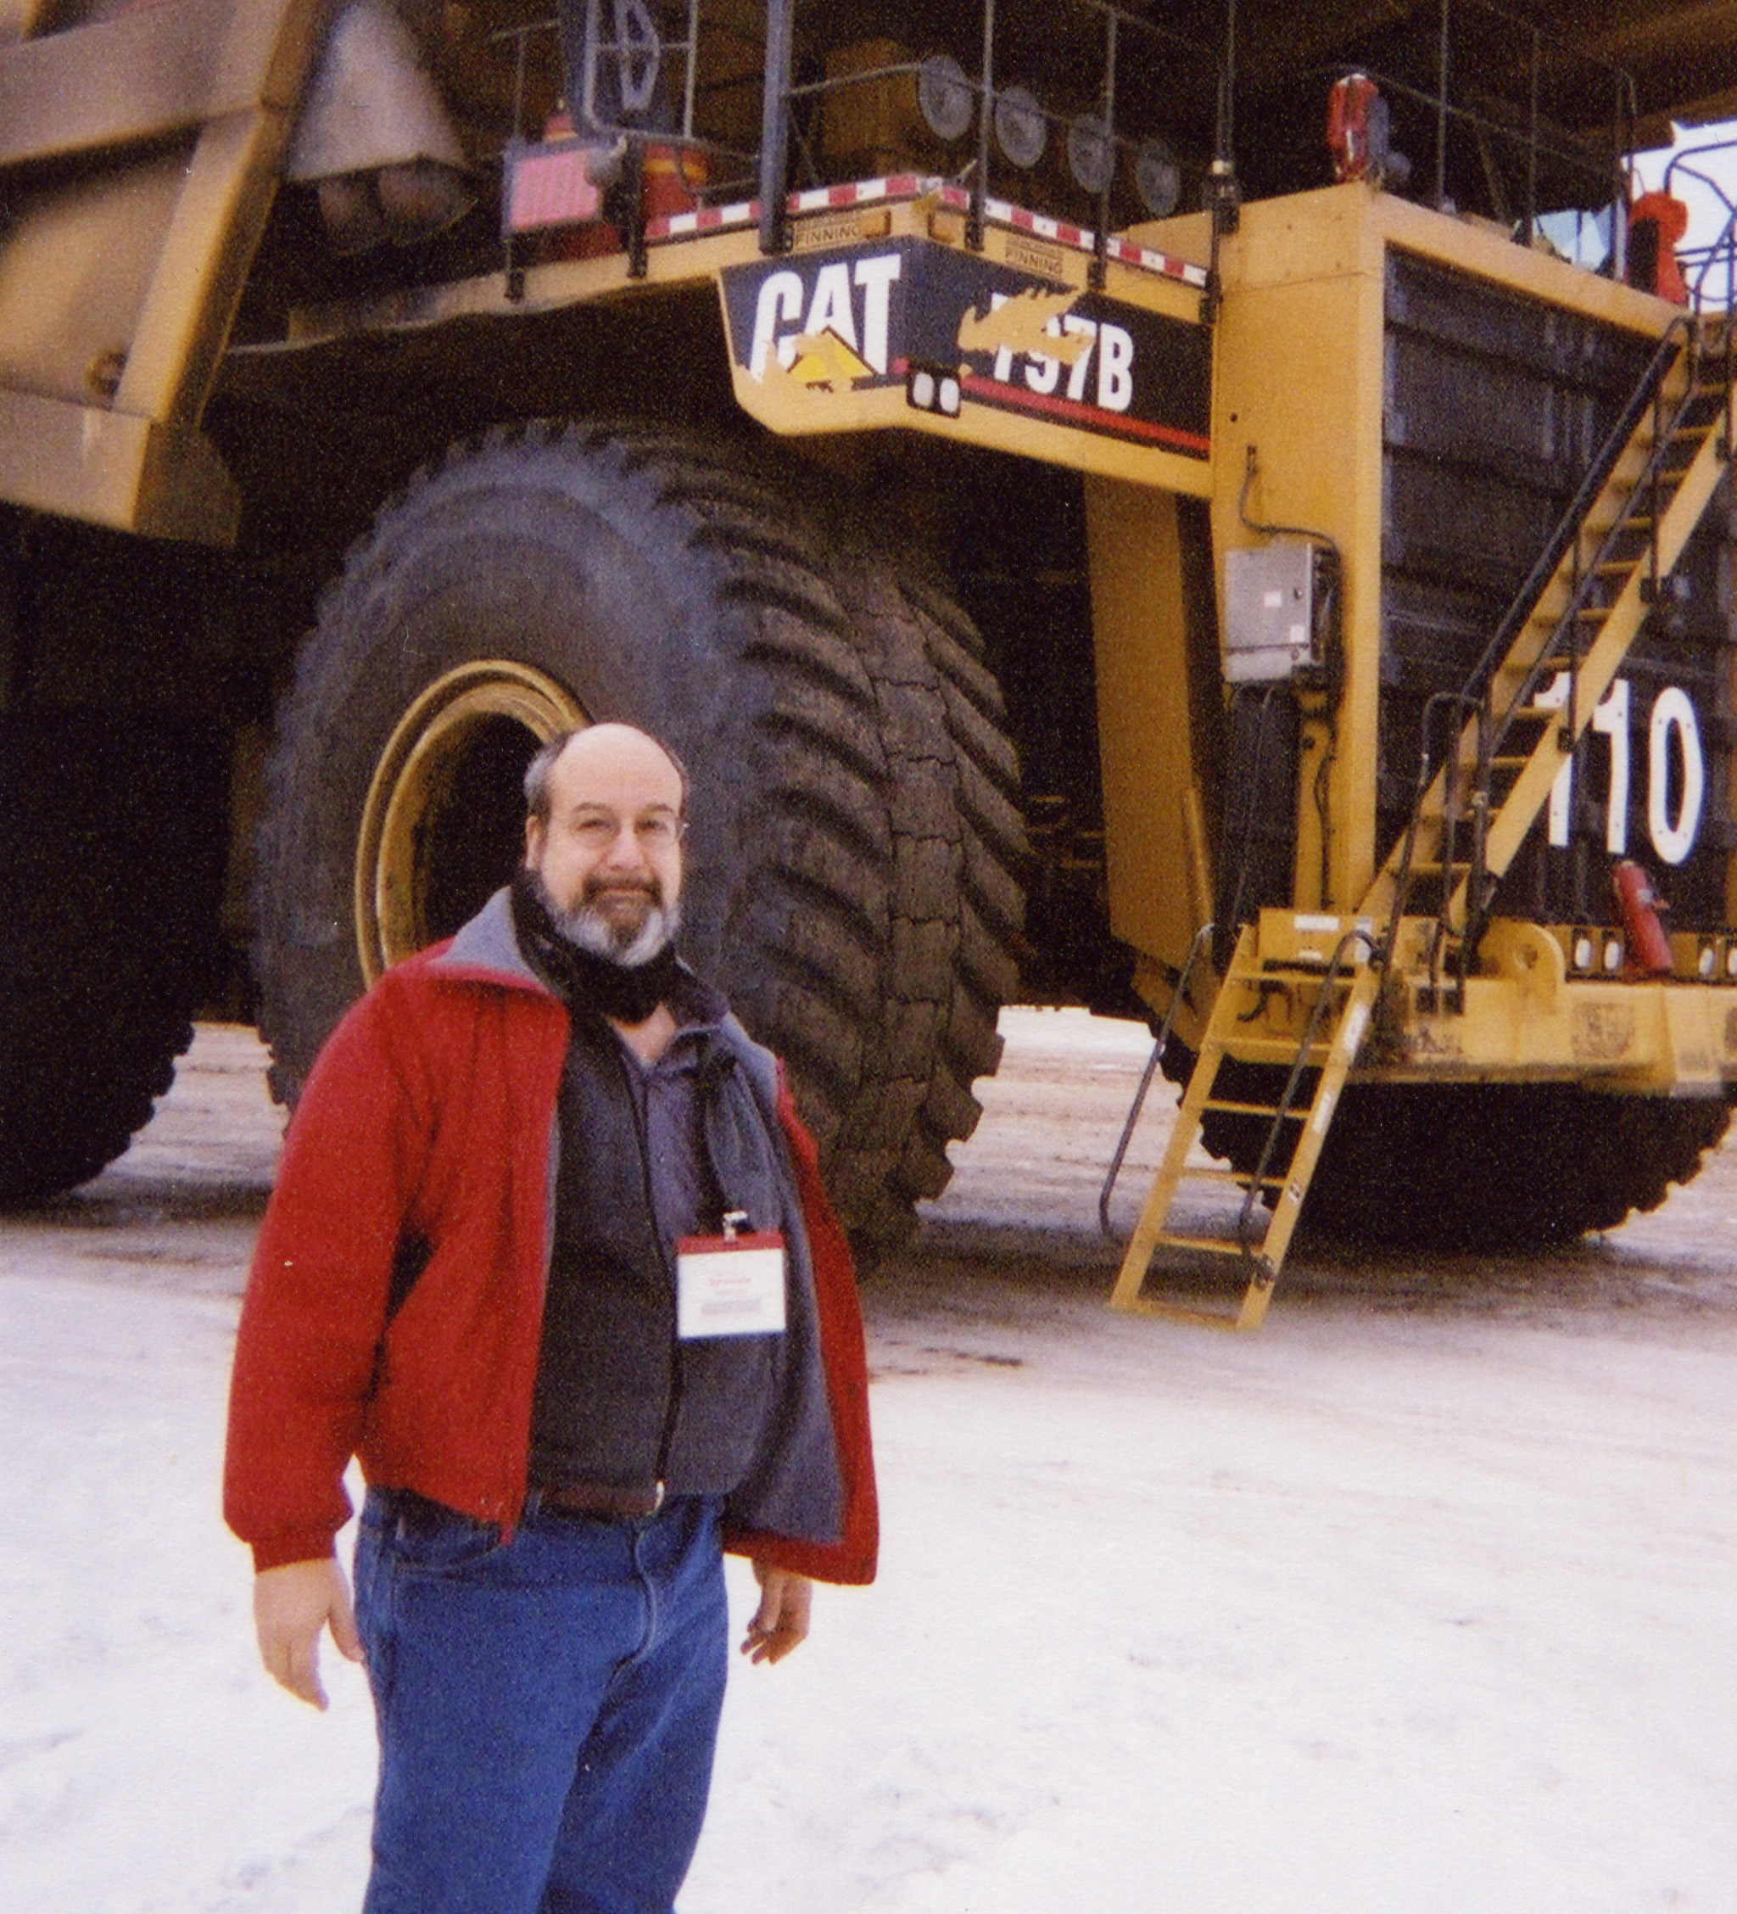
As we have conflict in the Middle East I’m reminded of the 1973 and 1979 oil embargos (I reveal my age). At that time the government funded studies to improve efficiency of heavy trucks and busses. One of the most successful programs was called the Voluntary Truck and Bus Fuel Economy Improvement Program (VTBFEIP)

The VTBFEIP and its members commissioned excellent research into the factors of fuel consumption and thoroughly investigated fuel savings techniques and devices. I was rereading some material I wrote almost 20 years ago and found the message seemed just as relevant today. Many of the more radical proposals of the VTBFEIP are now totally accepted.

Some background: what consumes the fuel?
Power- Fuel is consumed to generate power to turn the engine. Power is needed for four purposes:

1. It takes power to overcome inertial resistance to start the unit moving, or to accelerate the vehicle to needed speed. Power to overcome inertial resistance is determined by acceleration and gross mass. In addition to standard inertial resistance there is grade resistance. The amount of power required for long constant grades is:

(Note 1) HP Grade = 0.03645 * GM * G * V
Where GM is gross mass
G is grade in %
V is velocity
Note 1: This is a metric formula, expressed in Metric Tons, KM/HR

2. Friction causes rolling resistance. Rolling resistance is the tendency for the unit to slow down unless engine power is applied. It is the internal resistance of the bearings, drive train friction, the visco-elastic resistance of the tires against the pavement. The vehicle mass, road surface, and design all impact rolling resistance.

3. As the unit moves faster aerodynamic drag resistance (wind resistance) become the big factor. At 63 MPH wind resistance consumes 50% of the available power. The standard square shape (contrast truck shapes to airplanes or speed boats) requires high amounts of fuel to merely part the air. The height, width, shape and speed determine this resistance. Doubling the height or width (for the same shape) will double the wind resistance. Speed of the vehicle (or a head wind) has a major effect. Doubling the speed will increase the drag by 8.

4. Accessories include air conditioning, thermostatic fans, alternator, air compressor, and power steering pump, ECT. These items' use of power varies with engine speed (rather than road speed). The total of these loads varies from 3-4HP under light conditions to a maximum of about 35HP.

Total Power

The total of the four factors is the required power to do the job. The margin between the power needed and the power available is available for hills and acceleration. Note that the margin decreases as speed increases. Items that will impact fuel consumption will impact power.

The VTBFEIP Program Recommended Nine Areas to reduce Fuel Consumption

1. Steel belted radials reduce rolling resistance by 40%. Super singles decrease resistance additionally as well as provide mass (weight) improvements.

2. Improved lubricants can decrease rolling resistance 2-3%. These include ester based lubes or ones with additives such as molybdenum, Teflon, graphite. Run your own tests to separate the flashy ones from the ones that work. Additives have been shown to improve efficiency and reduce wear and tear. Only your testing in your environment will prove the claims.

3. Purchase smooth sided trailers with well-rounded corners. Fuel consumption gains for fairings are well established except knowledge of use is important. Roof fairings are only effective when used with vans. Performance is worse than before on dump trailers, flats, and bobtail. To maximize fuel efficiency the trucks/tractors of the future sport smooth wheel shirts, panels between the tractor and trailer and smooth curves on all corners. Smoothing and rounding will increase the efficiency of straight trucks and busses too.

4. Improve operational techniques. Improve routing to reduce mileage. If you are cube limited doubles will provide better fuel gallons per ton-mile. Running with full loads also improves efficiency and $/ton-mile.

5. Thermostatically controlled fans will reduce fuel use. In tests on 23 units the fans ran less than 3% of total engine hours. This can save 20HP on large engines.

6. Re-specify engine to more nearly match HP actually required, including turbocharged and reduced fuel consumption engines. Consider re-powering before you are about to do any major work on the engine. Specify gear train to minimize RPM at road speed. In all cases lightened components will reduce fuel consumption.

7. Govern engines to limit maximum speed. Remember wind resistance increases 8 times as speed increases twice. Also govern engines to operate at maximum fuel efficiency which is usually also near the maximum torque RPM.

8. Keep vehicle maintained and when replacing components use efficiency ones. Key areas include keeping air cleaners free, when replacing mufflers use low back pressure units, keep tire pressure right, change to disk wheels.

9. Improved driving practices can save 1-10% of your fuel bill. These include observe speed limits, keep RPM's down, shut off engine when not in use, avoid overfills, shift as little as possible.

These ideas still are important as we cope with increasing diesel costs and no (little) increase in revenue.



